**Hackathon Solution Documentation**

**WFAP Credit Negotiation System - Implementation Overview**

**System Architecture & WFAP Protocol**

Our WFAP Credit Negotiation System implements a sophisticated multi-agent ecosystem that enables intelligent loan negotiation between companies and banks. The system goes beyond the basic requirements by adding real-time negotiation capabilities, user interfaces, and advanced ESG integration.

1. **Core Architecture**

The system consists of four main components working together:

* **Consumer Agent** (The Negotiator): Acts as an intelligent CFO that sends loan requests, evaluates offers from multiple banks, and can negotiate better terms on behalf of the company.
* Three **Bank Agents** (The Lenders): Each represents a different banking philosophy - EcoGreen (ESG-focused), Traditional Trust (conservative), and InnovateTech (innovation-driven). Each agent evaluates loan requests based on their unique policies and risk models.
* FastAPI Backend (**The Communication Hub**): Serves as the central coordination point where all agents communicate through standardized WFAP protocols. It handles request routing, response validation, and audit logging.

1. **WFAP Protocol Implementation**

We defined comprehensive schemas for all communication:

* **Intent Structure**: Contains company identification, loan requirements (amount, duration, purpose), expected income, timestamp, and digital signature for verification.
* **Offer Structure**: Includes bank identification, approved amount, interest rates (standard and carbon-adjusted), repayment terms, ESG impact summary, and cryptographic signature.
* **Validation Rules**: All messages are validated against JSON schemas to ensure protocol compliance. Digital signatures verify sender authenticity and prevent tampering.

1. **Security & Compliance**

Every interaction is secured through HMAC signatures. The system maintains complete audit trails showing how each agent verified identities, made decisions, and communicated results. This ensures regulatory compliance and provides transparency for all financial negotiations.

**Agent Implementation & Business Logic**

1. **Bank Agent Implementation**

Each bank agent operates with distinct personality and decision-making criteria:

* Bank 1 (EcoGreen Financial) specializes in sustainable lending. It heavily weights ESG factors in its evaluation, offers preferential rates for green projects, and automatically calculates carbon-adjusted interest rates that reward environmentally positive business activities.
* Bank 2 (Traditional Trust Bank) follows conservative banking principles. It prioritizes financial stability, conducts thorough risk assessments based on repayment capacity, and maintains traditional lending standards with moderate ESG consideration.
* Bank 3 (InnovateTech Financial) focuses on technological innovation. It evaluates loan requests based on growth potential, technological advancement, and future market disruption potential, offering competitive terms for cutting-edge business models.

1. **Consumer Agent Logic**

The consumer agent employs a sophisticated weighted scoring system to evaluate offers:

* Carbon-adjusted interest rate receives the highest priority (35% weight) as it represents both financial cost and environmental impact
* Amount approved is heavily weighted (30%) since loan size directly affects business capabilities
* ESG compliance score contributes 20% to recognize banks that align with sustainability goals
* Base interest rate and repayment flexibility receive 10% and 5% respectively

The agent calculates normalized scores for each criterion, applies the weights, and selects the offer with the highest total score. In case of ties, it prioritizes higher loan amounts and lower interest rates.

1. **ESG Integration**

Environmental, Social, and Governance factors are deeply integrated throughout the system. Each bank agent analyzes the business purpose using natural language processing to assign ESG scores. These scores influence interest rate calculations, with sustainable projects receiving carbon-adjusted discounts. The system promotes responsible lending by making ESG performance a key decision factor.

1. **Negotiation System**

Our innovative extension allows real-time interest rate negotiation. When a user requests better terms, the consumer agent contacts the bank agent directly. Each bank has predefined negotiation boundaries:

* Maximum reduction limits (0.3% to 0.7% depending on bank)
* Minimum rate floors (4.0% to 5.0% depending on bank)
* Policy-based approval logic

If the bank agrees to the new terms, the offer updates immediately with the negotiated rate and an updated ESG summary reflecting the improved terms.

**User Experience & Technical Features**

1. **Technical Implementation Details**

* **Backend Processing**: Built with FastAPI for high-performance async operations. The system handles concurrent requests from multiple agents while maintaining data consistency and audit trails.
* **Agent Communication**: Uses LangChain for orchestrating complex agent interactions. Each agent operates with specialized tools for identity verification, risk assessment, ESG analysis, and negotiation.
* **Data Persistence**: Maintains complete transaction history in JSON format, allowing users to review past loan requests and their outcomes.
* **Error Handling**: Comprehensive error management ensures the system gracefully handles network issues, invalid requests, and agent communication failures.

**Screenshots**

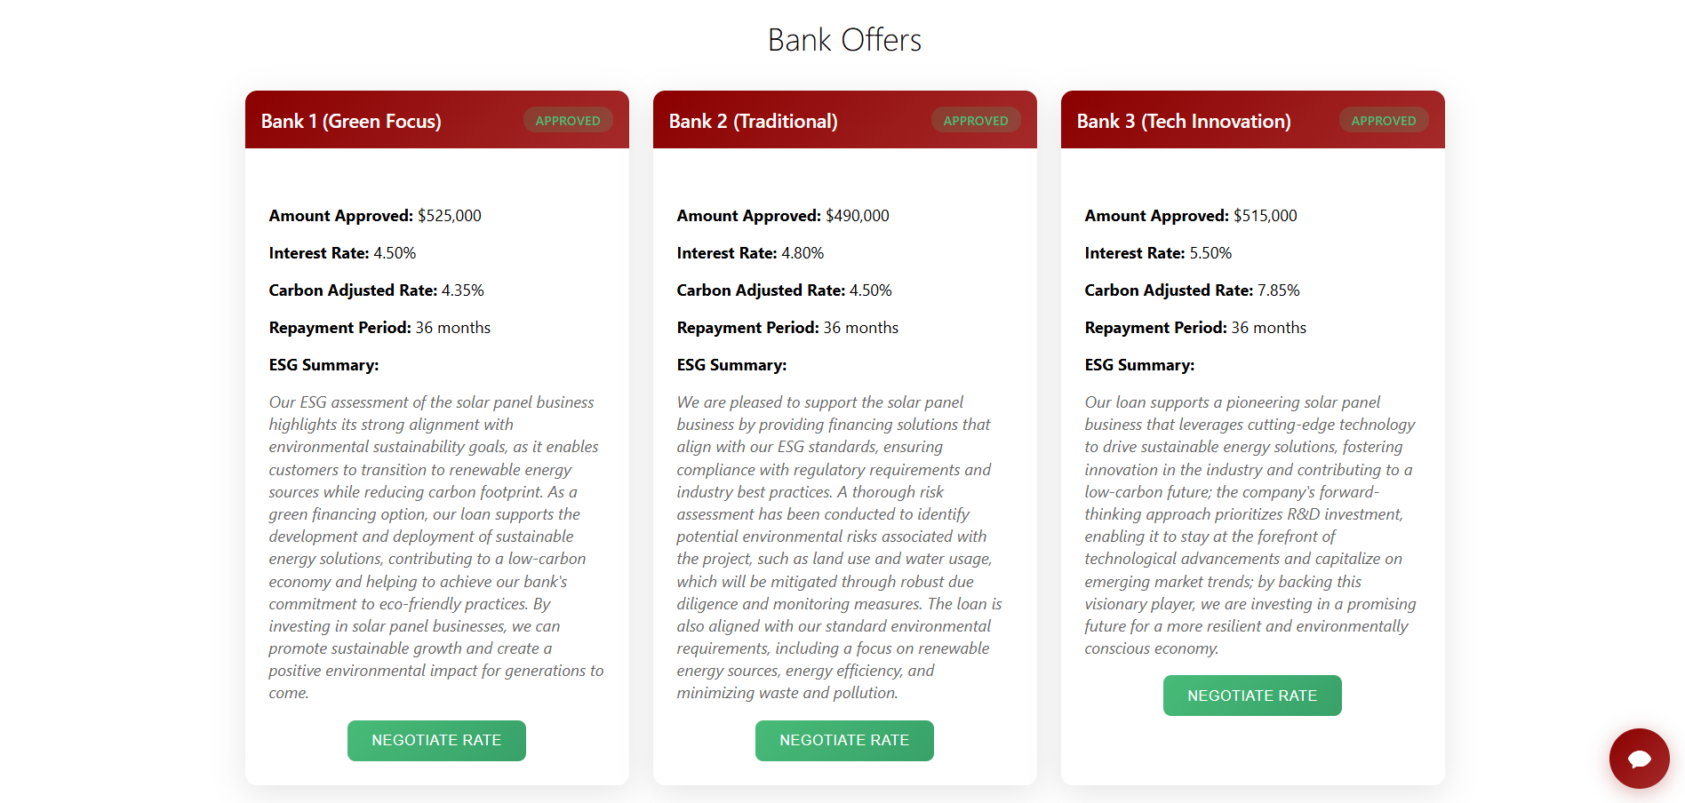

Displaying the previous chosen bank offers

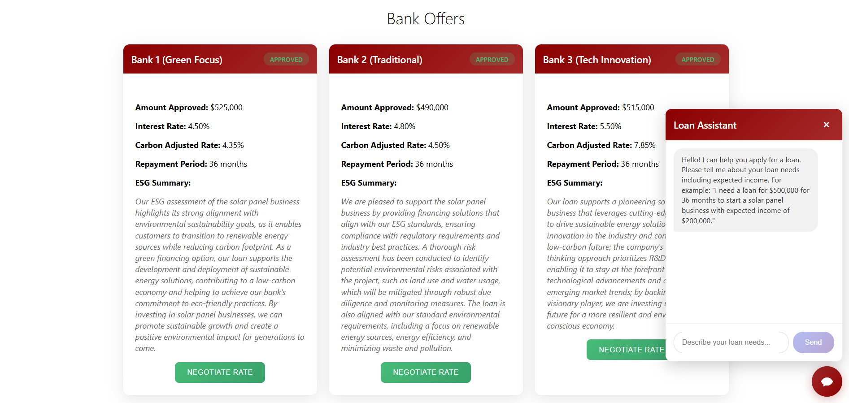

Chatbot for quering about Loans

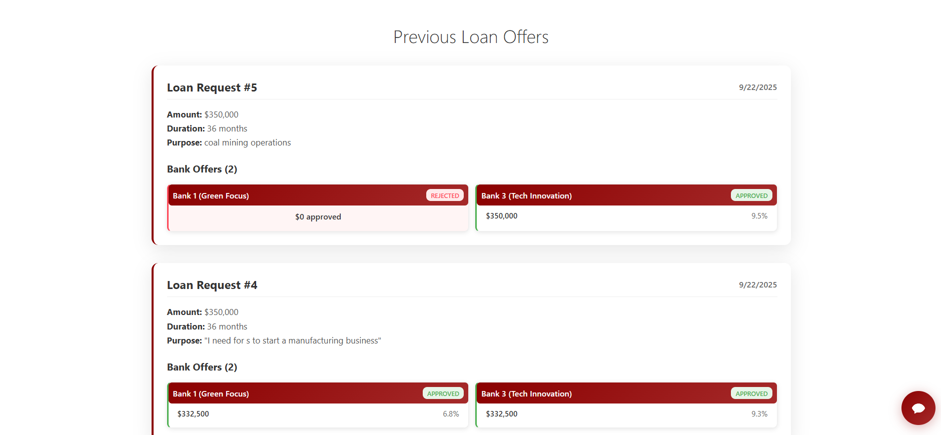

Displaying previous loan requests